**Technical Assessment**

Ques- 1 Write a program to print all the possible unique combinations of characters in a given string.

i.e TRUE, RTUE, EUTR, UTRE………………………………….

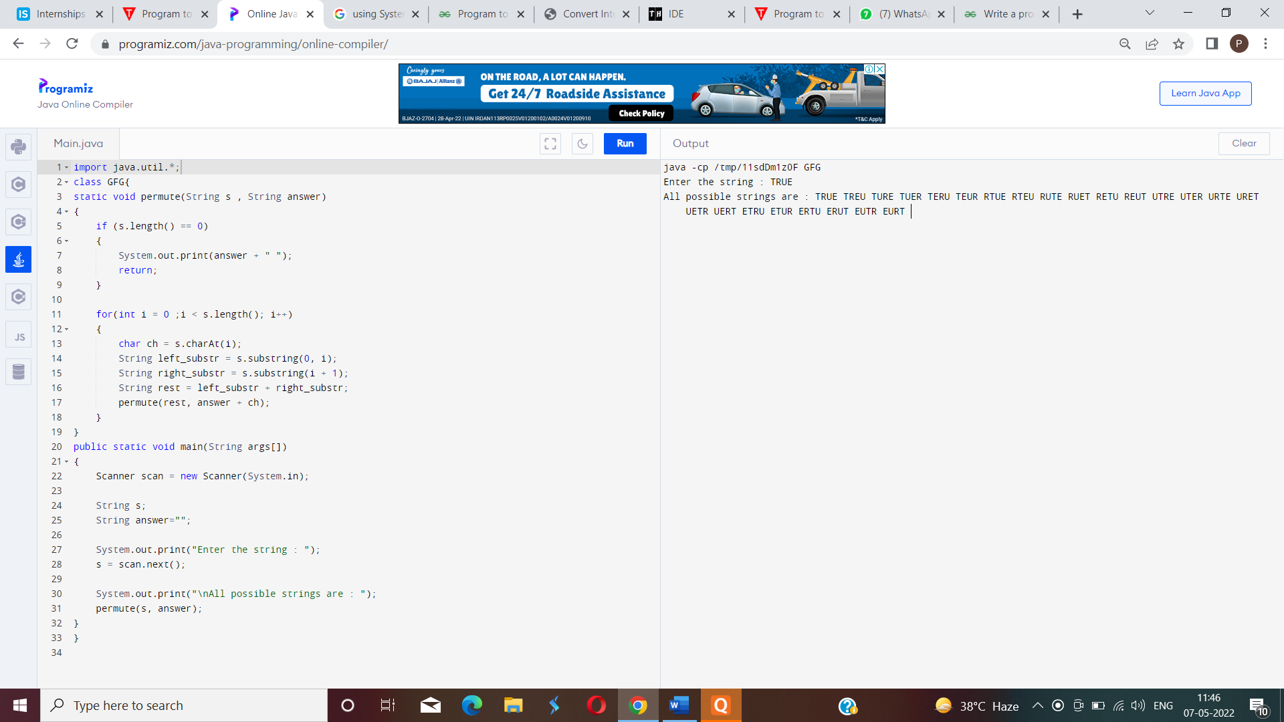

Que-2 Write a program to convert any integer number between 1 to 500 in to Roman Expression.

I, II, III, IV,V,VI,VII,VIII,IX

50-L, 100-C, 500-D

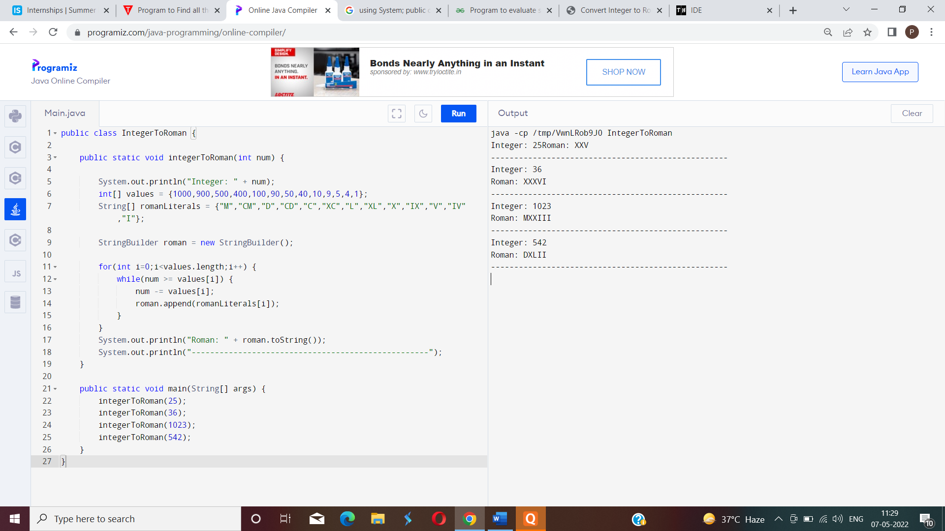

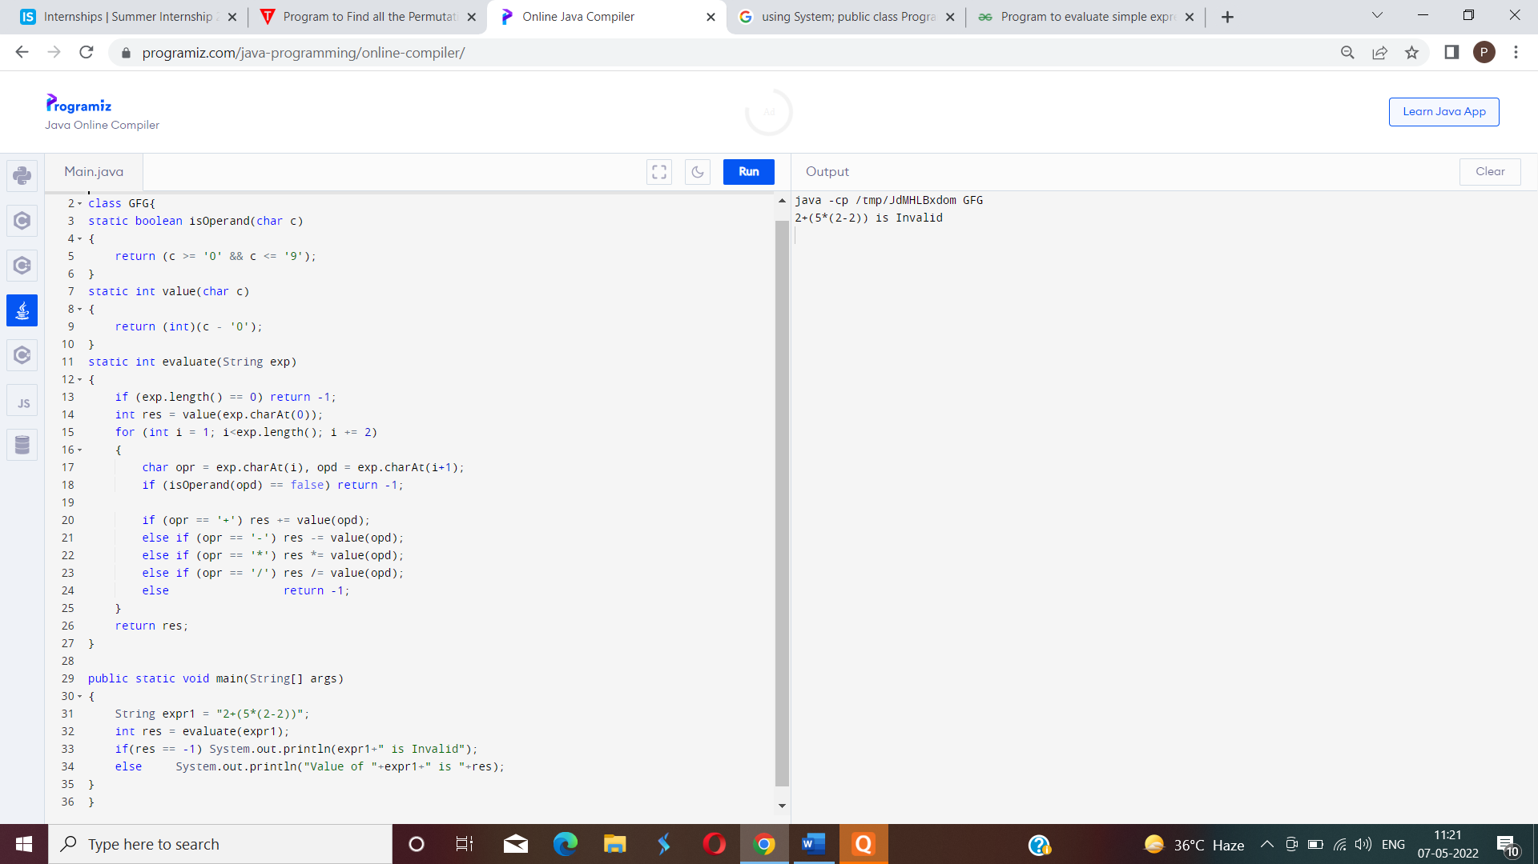Que-3 Write a program to evaluate a expression using BODMASS approach.i.e. string expression=”2+(5*(2-2))”